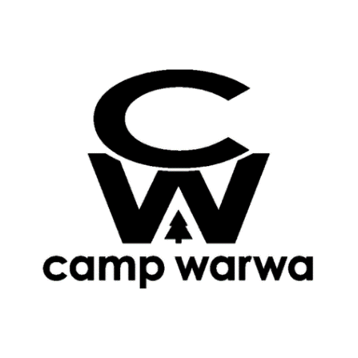
Food Service Coordinator

Job Summary
Camp Warwa makes a difference in the lives of children by giving them unforgettable outdoor experiences. We believe that people care about what they are connected to; and all our programs support campers in connecting with themselves, connecting with community, connecting with nature, and connecting to the generations. A non-profit charity founded in 1980, Camp Warwa is a year-round outdoor education center that serves over 8,000 children annually.

The Food Service Coordinator is a member of our leadership team. Their primary role is to implement meal services for Camp Warwa and supervise Kitchen Staff. In the summer season, Camp operates from Monday through Friday. In the spring and fall, some weekend work is required, depending on bookings. The Food Service Coordinator is expected to work 35-40 hours per week at camp. The Food Service Supervisor is the main contact for Kitchen staff.

Camp Warwa is led by a collaborative leadership community. Our organizational culture is cooperative, welcoming and carries a strong commitment to mentoring and professional development.

Responsibilities and Duties
Core responsibilities of the Food Service Coordinator includes:
- Meal planning and food order
- Meal service for clients and staff
- Positive and effective Kitchen Staff management
- Ensuring dietary needs are met
- Ensuring food safety requirements are met and cleaning procedures are completed effectively

The Food Service Coordinator position is seasonal, full time, with some opportunities for casual off season work.

Qualifications and Skills
Food Service Coordinator will have food service and kitchen experience, and will be passionate about providing healthy, balanced meals to clients and staff. They will have commercial kitchen experience or be currently enrolled in a related program of study. A Criminal Reference Check and Standard First Aid with CPR-C are required.

Salary and Benefits
$18.50 - $24.00/hour. On-site room and board available, with access to Wi-Fi and laundry, although living on site is not required.

Start and End Dates
Spring and Summer Seasons: April 21 – August 23
Fall Season: September 1 – November 9
* start/end dates subject to change

To apply, email resume to gerrit@campwarwa.org

